1. Data Cleaning and Processing

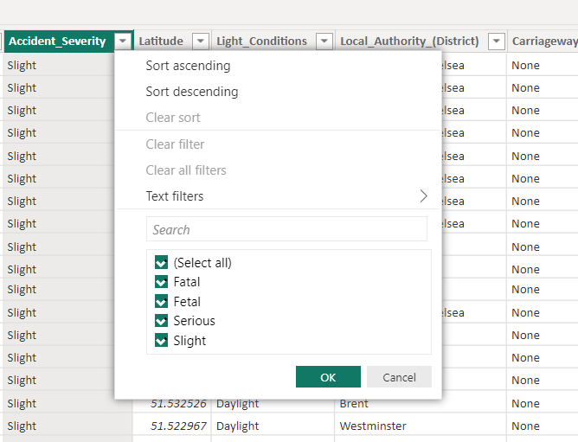

Go to transform data   
one power query editor window is open

Click on particular column  
change as replace value option

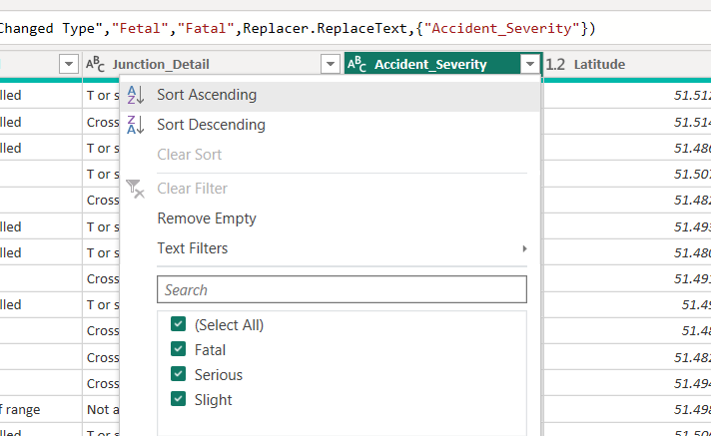

Data processing

Add new table , if in our data date column is there   
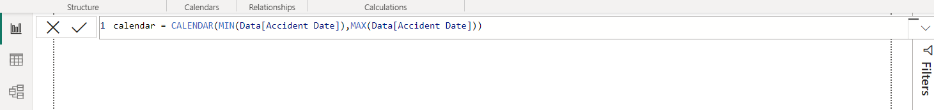

New table   
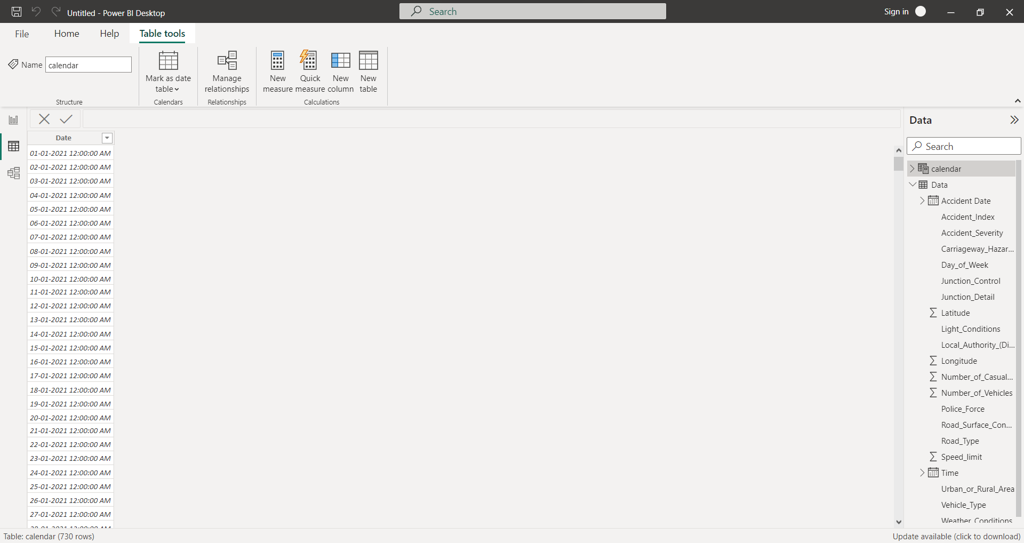

Add column as year   
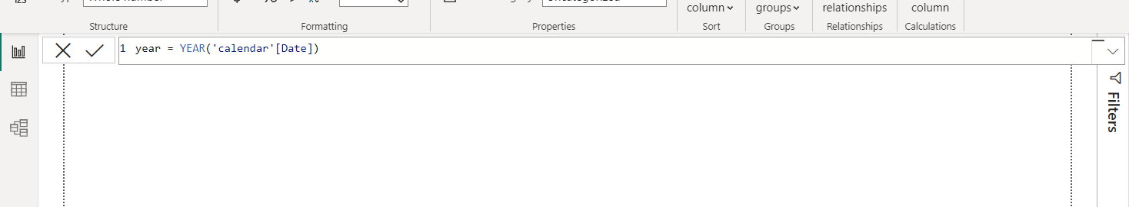

Add month   
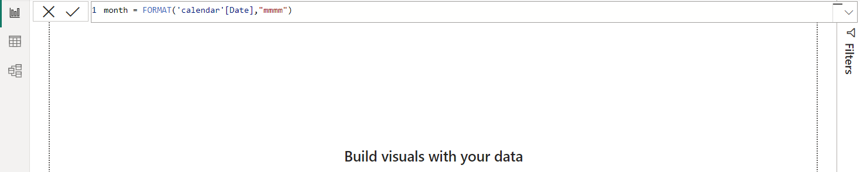

New column

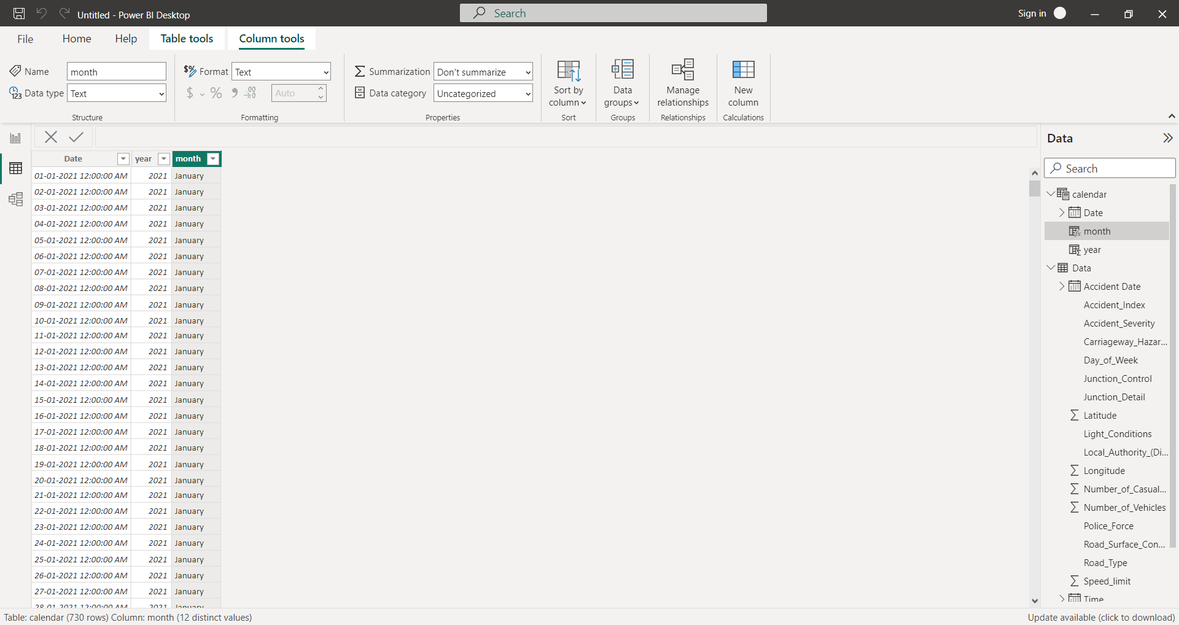

Data modelling

Now we have to join two tables

Table one is “ data”

Table two is “ calendar”  
  
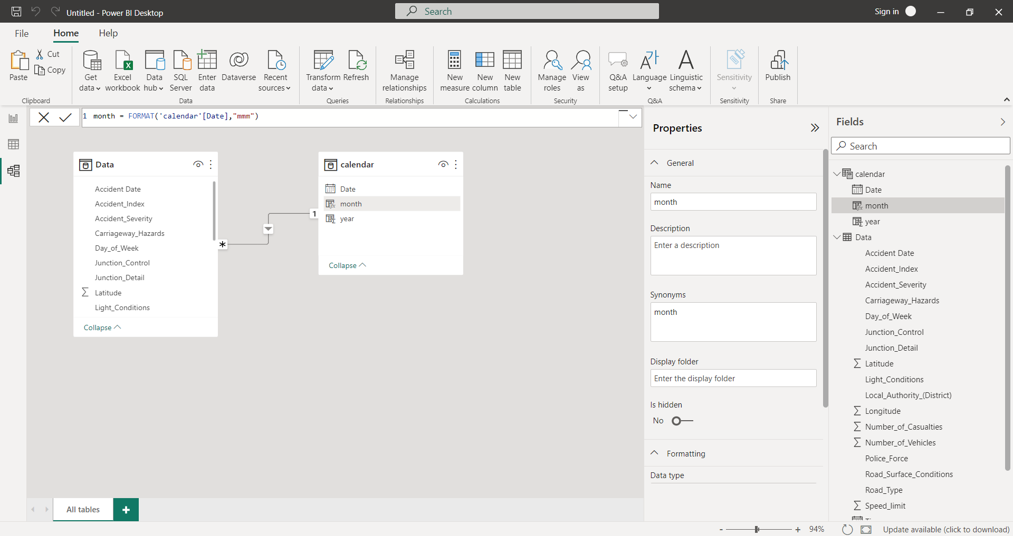

ONE TO MANY RELATIONSHIP